Behind the Smile of the Sri Lankan
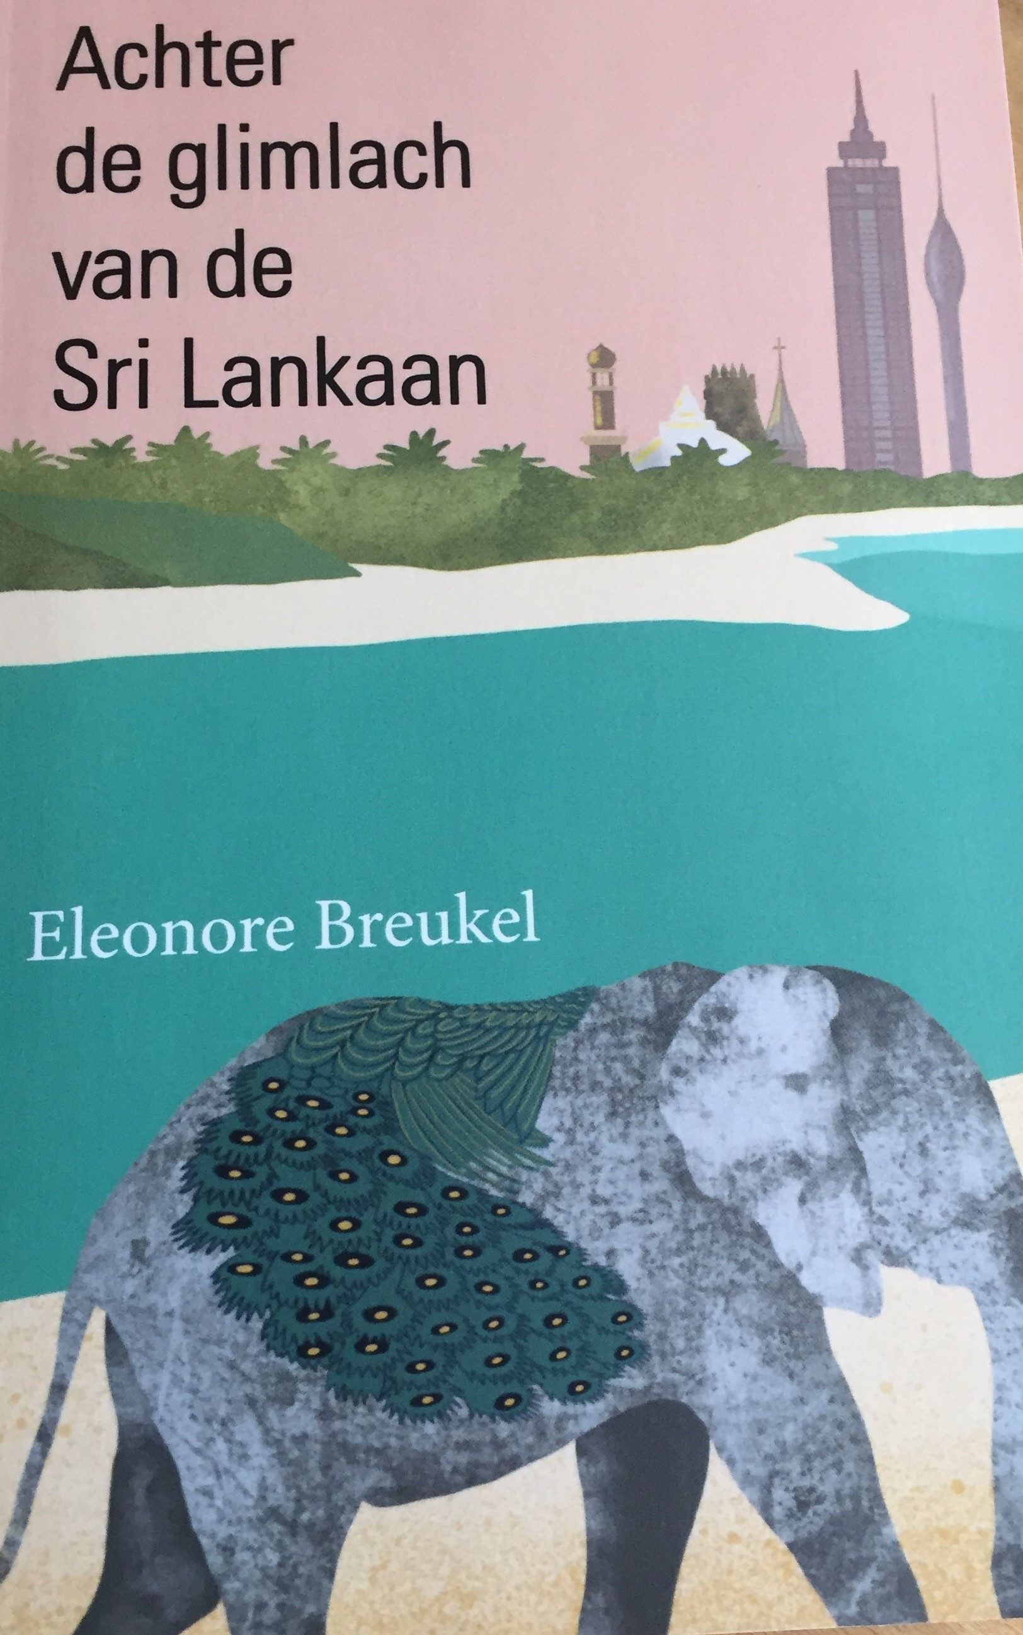
“Translation of synopsis”

Whatever is so magical about the apparent paradise-like Sri Lanka?
What is behind that generous smile. Sri Lankans talk about their lives,
about the clashing cultures of the Buddhist Sinhalese, Hindu Tamils,
Muslims, Christians and Burghers, and the social heritage of
the Portuguese, Dutch, and British colonizers. How the elite of yore
still rules politics and business, and how language divides the nation.

Tourists travel through the backdrop of beautiful temples, fortresses,
tea plantations, and jungle in which perky elephants and peacocks roam.
A glimpse behind the scenes shows a different reality: strong cultural
traditions at births and marriages, strict observance of the horoscope,
and continually emerging ethnic violence. In the daily struggle for
existence, in a culture where time is elastic and the truth flexible,
the Sri Lankan remains resilient and hospitable.

Enterprising expats, foreign investors, and Sri Lankans in the diaspora use the highway to modernity. Tower apartments rise between the temples. Major powers are building motorways and ports, in particular, to serve their own purposes. Due to the island's favorable geopolitical location, the power of China, India, and the US is visible.
Does the Sri Lankan still feel "at home" in his own country?

Eleonore Breukel is an Intercultural Management Consultant. She lived in Paris, Rome, London, Athens, and Curaçao. Moreover, work took her to forty countries. Amsterdam is her base, Sri Lanka, her second home. She has published numerous culture-related articles and is co-author of Wereldwijd Zakendoen (Doing Business Worldwide 2000).
www.intercultural.nl

Chapters
1. Having a burger with a Burgher

2. Street culture

3. Beach residents

4. Whoever takes the railway is derailed

5. Beauty blinks in the tears of the North

6. Jaffna

7. Forgotten islands

8. The battle continues

9. Divide and rule, the power of language

10. Colombo's marriage market

11. Captains of Industry

12. Observing the horoscope

13. On the highway to modernity

14. Behind the smile of the Sri Lankan

Book available here

